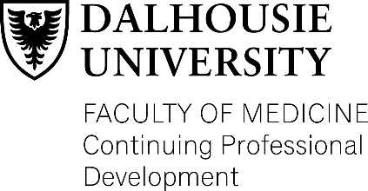
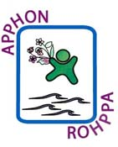
2020 APPHON/ROHPPA Conference

AGENDA

Friday, November 13th, 2020
Virtual

0800 Welcome and Introduction - Dr. Bruce Crooks
0810 Guidelines Update - Dr. Tamara MacDonald
0900 Leukemia Update - Dr. Stephanie Villeneuve
0945 Break
1000 Rare Bloodwork - Dr. Lisa Goodyear
1045 Chemotherapy Side Effects - Christa McGuirk, CNS
1130 Fertility Guideline - Dr. Craig Erker
1215 AGM - Carol Digout
1230 Lunch
1315 BMT/Cellular Therapy Update - Dr. Donna Wall, Sick Kids
1415 Sickle Cell Emergencies - Dr. Bilal Marwa
1515 Break
1530 Cannabis and Palliative Care - Dr. Robin Williams
1615 Distraction Techniques - Tracy Warren & Jennifer LeBlanc
1645 COVID -19 – Pediatrician’s Perspective - Dr. Heather Flieger & Dr. Kathryn Bigsby
1715 Adjourn

This event is an Accredited Group Learning Activity (Section 1) as defined by the Maintenance of Certification Program of the Royal College of Physicians and Surgeons of Canada, and approved by Continuing Professional Development, Dalhousie University. You may claim a maximum of 7.75 hours (credits are automatically calculated).

Through an agreement between the Royal College of Physicians and Surgeons of Canada and the American Medical Association, physicians may convert Royal College MOC credits to AMA PRA Category 1 Credits™. Information on the process to convert Royal College MOC credit to AMA credit can be found at http://www.ama-assn.org/go/internationalcme .

