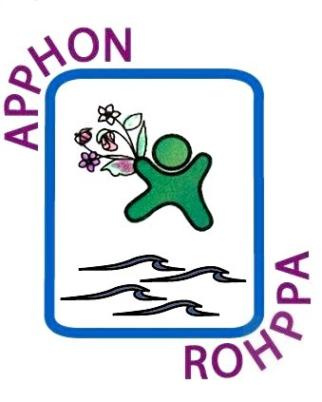

REGISTRATION FORM
APPHON/ROHPPA ANNUAL Conference
Via GoToMeeting - Virtual
November 13, 2020
8:30am – 4:30pm

Name:

Address: _____________________________________________________________

Phone: Fax:

Email: Profession: _______________________

Affiliated Hospital/Organization:

This virtual conference will be available via GoToMeeting.
A meeting invitation with log in information will be sent to all registrants
& will be available on our website.
*Please note if you require confirmation of attendance, you must register.

Any questions, please contact Carol Digout by phone (902) 470-7429
or via email, carol.digout@iwk.nshealth.ca

Please return form to:

Carol Digout, APPHON/ROHPPA, c/o IWK Health Centre, 5850 University Avenue,
PO Box 9700, 6th Floor Link, Room #610, Halifax NS, B3K 6R8

Fax registration form to: (902) 470-6510

