REGISTRATION FORM
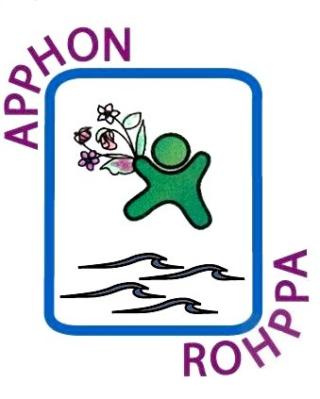
APPHON/ROHPPA ANNUAL Conference
Via GoToMeeting - Virtual
November 13, 2020
8:00am – 5:15pm

Name:

Address: _____________________________________________________________

Phone: Fax:

Email: Profession: _______________________

Affiliated Hospital/Organization:

This virtual conference will be available via GoToMeeting.
A meeting invitation with log in information will be sent to all registrants
& will be available on our website.
*Please note if you require confirmation of attendance, you must register.

Any questions, please contact Carol Digout by phone (902) 470-7429
or via email, carol.digout@iwk.nshealth.ca

Please return form to:

Carol Digout, APPHON/ROHPPA, c/o IWK Health Centre, 5850 University Avenue,
PO Box 9700, 6th Floor Link, Room #610, Halifax NS, B3K 6R8

Fax registration form to: (902) 470-6510

This event is an Accredited Group Learning Activity (Section 1) as defined by the Maintenance of Certification Program of the Royal College of Physicians and Surgeons of Canada, and approved by Continuing Professional Development, Dalhousie University. You may claim a maximum of 7.75 hours (credits are automatically calculated).

Through an agreement between the Royal College of Physicians and Surgeons of Canada and the American Medical Association, physicians may convert Royal College MOC credits to AMA PRA Category 1 Credits™. Information on the process to convert Royal College MOC credit to AMA credit can be found at http://www.ama-assn.org/go/internationalcme .

